
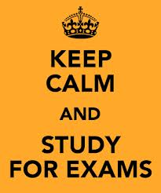

Guidance for the use of calculators in exams

Students must currently provide their own calculator for use in exams where one is permitted. If in doubt, we suggest consulting the teacher in the subject concerned well in advance to find out in which papers calculators are permitted.
Lids are not allowed and must be left outside the exam venue. We cannot be responsible for any that are handed in once in the exam room.
Students are responsible for putting any calculator into mode where this is necessary. Invigilators are instructed not to offer advice on this.
In particular, students using a graphical calculator must ensure that it is in exam mode before going into the exam venue, and that they know how to show the elapsed time to an invigilator. Any student who does not do both of these things may not use the calculator in the exam, and risks disqualification if they do.

